Report Type: Original Report

Template for Submitting a Paper in English
―Place any subtitle on the second line―

Authors
Minato Aroma,*¹ Shota Kankyo,¹ Rinka Seiyu²

1: Official name of the institution with which the authors are affiliated
2: Official name of the institution with which the author is affiliated

Contact information
Address: Provide the address of the author marked with an asterisk (*).
TEL: Provide the telephone number of the author marked with an asterisk (*).
Mail: Provide the e-mail address of the author marked with an asterisk (*).
No. of tables: 4
No. of figures: 3

Abstract
This template is a document created for submitting a paper to the Journal of Aromatherapy. It includes the contents of the submission guide, so we hope you will use this template to standardize the format and streamline the peer review process.
Please use 12-point font and print horizontally with the line number written in the left margin and the page number in the bottom right margin. The length of the abstract should be within 600 words for original articles and reviews, and approximately 100 to 200 words for notes and case reports.

Keywords: aroma, essential oil, EEG, relaxation, olfaction

1. Introduction
The main text sections should be organized according to the submission guidelines: 3-1. Original Reports, 3-2. Reviews, 3-3. Study Notes, and 3-4. Case Reports. Level 1 headings, such as 1. Introduction and 2. Methods, should be centered on the page.

2. Materials and Methods
2.1 Subjects
Level 2 headings (subheadings under Level 1) should be numbered as 2.1, 2.2, etc., while Level 3 headings (subheadings under Level 2) should be numbered as 2.1.1, 2.1.2, etc. Both Level 2 and Level 3 headings should be indented by one space from the left margin. Subheadings under Level 3 or lower should be numbered sequentially as (1), (2), and so forth.
2.2 Measurement Conditionsa one space
・・・
2.2.1 Intervention Methods
(1) Samples
Given their importance for the editorial standards of the Journal of Aromatherapy, essential oils used in the study must be clearly identified with required information, including the scientific names of source plants, countries of origin, and names of manufacturers or importers. For these essential oils, it is preferable that aroma component analysis results are available from the distributor. This requirement does not apply to review articles.
(2) Sample presentation
・・・
2.2.2 Measurement of Brain Waves
・・・

3. Results
Figures, tables, and photographs should generally be limited to one per page and placed immediately after the corresponding main text. The total number of figures, tables, and photographs should not exceed 10. Each figure or photograph must include a number, title, and caption. Titles and captions of all figures and photographs should also be listed collectively on a separate page titled Figure or Photo Caption(s).
Tables should be labeled as “Table 1,” “Table 2,” etc. When citing tables in the text, refer to them by their labels (e.g., Table 1).
Figures should be labeled as “Fig. 1,” “Fig. 2,” etc., and cited in the main text accordingly.
Photographs should be labeled as “Photo 1,” “Photo 2,” etc., and cited in the main text accordingly.
The letter “p” in p-values denoting statistical significance should be italicized.

4. Discussion
References and notes in the main text should be numbered consecutively (e.g., XXX¹, XXX², XXX³, or XXX⁴–⁶) and placed in superscript immediately after the first relevant word. All references and notes should be listed at the end of the main text in the order they are cited.

5. References
1) William S. C., Joseph C. S.: Ann. NY Acad. Sci.,561, 29–38 (1989).

2) Shinzo Noda, Eri Daitoku, Wataru Okazaki: Japan Journal of Aromatherapy, 4, 26-29(2004).

3) Sawamura M. (Ed.): “Citrus Essential Oils. Flavor and Fragrance”, pp. 5-7, John Wiley & Sons, New Jersey (2010).

4) 鳥居鎮夫：“香りの謎”，pp. 35‒39, フレグランスジャーナル社, 東京(1994).

5) Aroma Environment Association of Japan (2014), Aroma Science Research Institute, September 10, 2014, < https://www.aromakankyo.or.jp/basics/literature/study/>, accessed December 10, 2014

Declarations / Article Information
Funding
Please provide information on any public or private grants received for this research.

Conflict of Interest
Declare any financial or personal relationships with external organizations (e.g., corporations) that could potentially influence the research findings or their interpretation.

Ethics Statement
If the study involves human participants, please provide details regarding the ethical standards followed and official approval.

Author Contributions
Specify the individual contributions of each author to the research (e.g., conception, experiments, writing, supervision).

Supplementary Materials
Include this section if there are additional data (videos, high-resolution images, large datasets, code, etc.) that support the main text.

Data Availability Statement
Provide information on how the data supporting the findings of this study can be accessed, including whether it is publicly available.

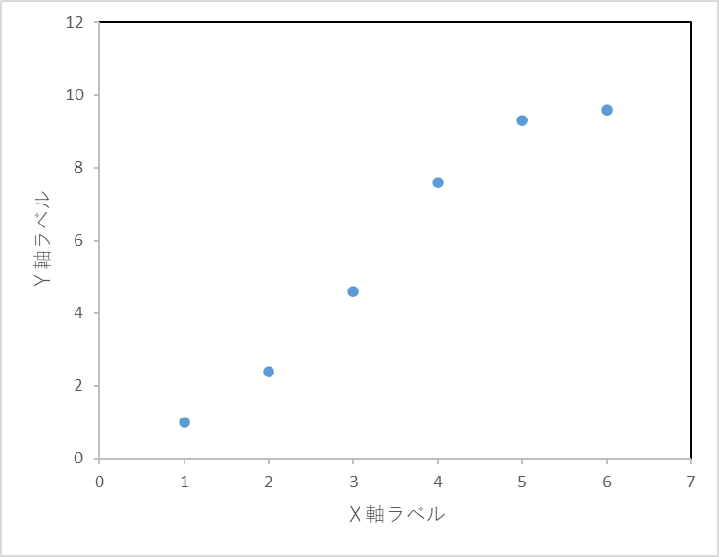
Figure 1. Provide the title and caption of a figure, table, or photograph

(Japan Journal of Aromatherapy, Template for submitting a paper in English; created on 04/01, 2026)

